**DAILY ONLINE ACTIVITIES SUMMARY**

|  |  |  |  |  |  |  |  |
| --- | --- | --- | --- | --- | --- | --- | --- |
| **Date:** | **21/05/2020** | | | | **Name:** | **Rachana B S** | |
| **Sem & Sec** | **4th sem B sec** | | | | **USN:** | **4AL18CS065** | |
| **Online Test Summary** | | | | | | | |
| **Subject** | | **Microcontroller and Embedded Systems** | | | | | |
| **Max. Marks** | | **30** | | **Score** | | **18** | |
| **Certification Course Summary** | | | | | | | |
| **Course** | **Introduction to R** | | | | | | |
| **Certificate Provider** | | | **1.Great Learning Academy** | **Duration** | | | **2.5 hrs** |
| **Coding Challenges** | | | | | | | |
| **Problem Statement: 1.A user will input two strings, and we find if one of the strings is a sub sequence of the other. Program prints “yes” if either the first string is a sub sequence of the second string or the second string is a sub sequence of the first string.**  Assume that, the length of the first string is smaller than or equal to the length of the second string. | | | | | | | |
| **Status: Done** | | | | | | | |
| **Uploaded the report in Github** | | | | **Yes** | | | |
| **If yes Repository name** | | | | **Lockdown coding** | | | |
| **Uploaded the report in slack** | | | | **Yes** | | | |

Online Test Details: Online test of Microcontroller and Embedded Systems was conducted .It was based on first module .There where 30 questions of 1mark each.

Snapshot:

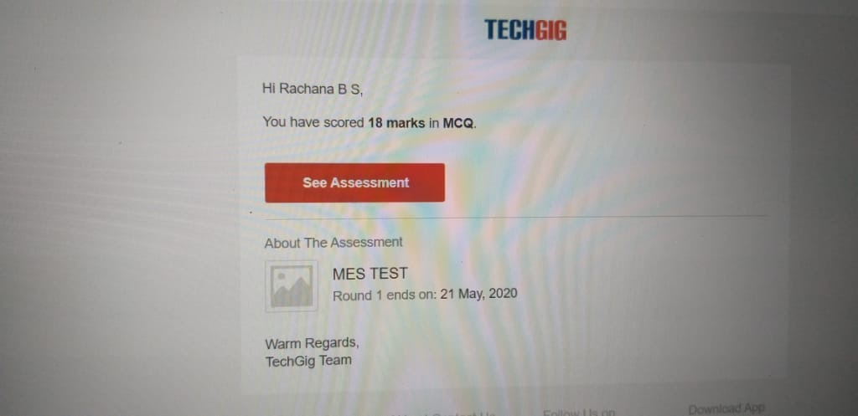

Certification Course Details: Today in Great Learning Academy, I learnt about Introduction to R.

**Snapshot**

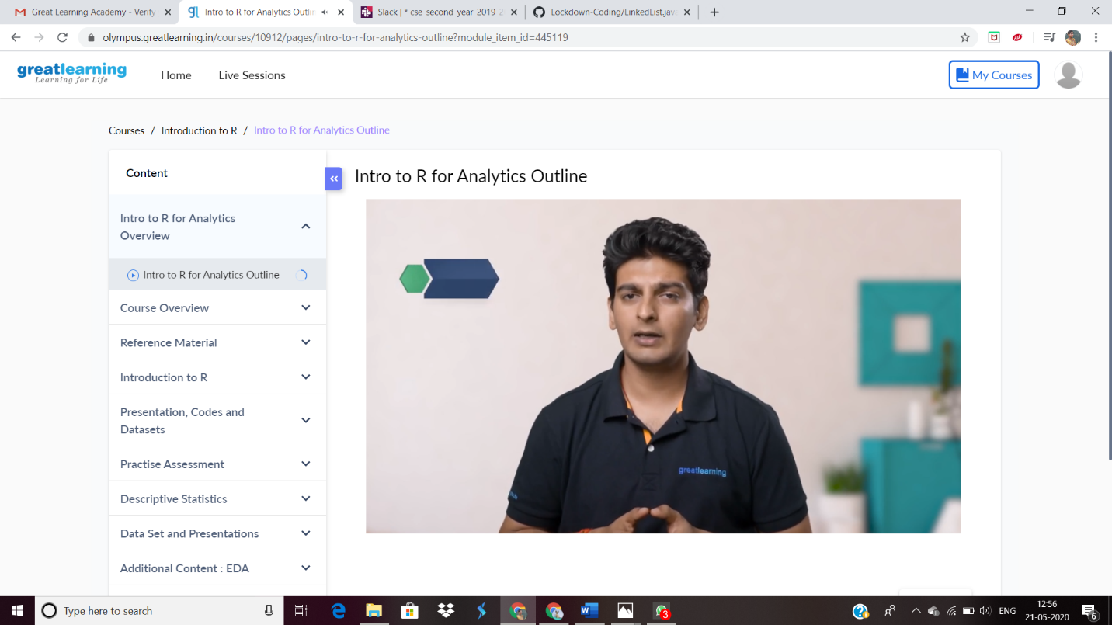

Coding Challenges Details: Problem Statements

**Question: A user will input two strings, and we find if one of the strings is a sub sequence of the other. Program prints “yes” if either the first string is a sub sequence of the second string or the second string is a sub sequence of the first string.**

Assume that, the length of the first string is smaller than or equal to the length of the second string.

**Solution : Uploaded in Github**

**Snapshot:**

